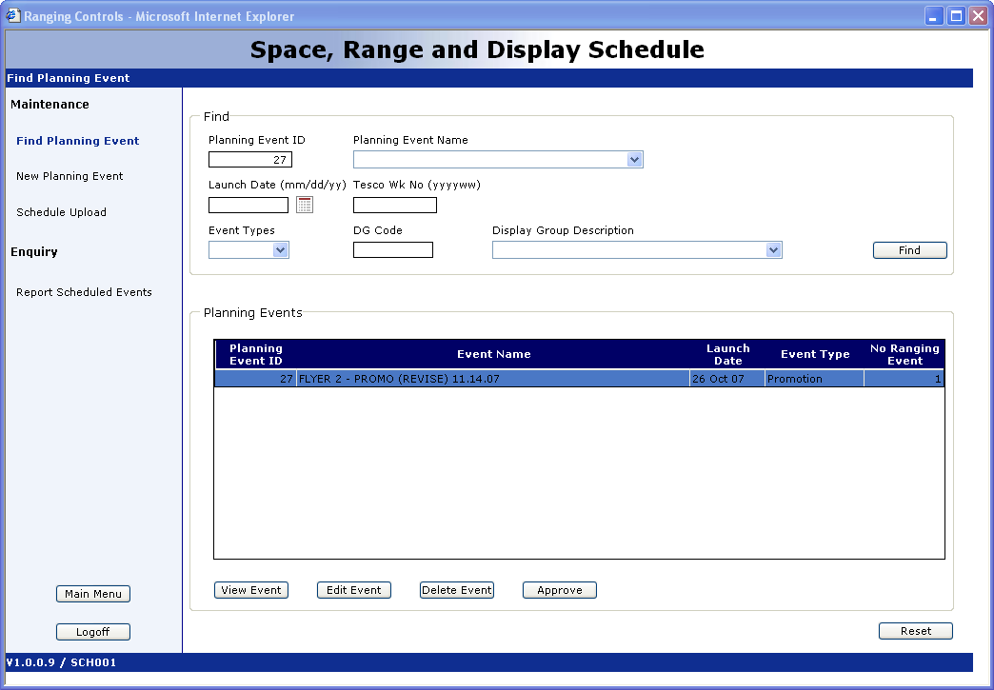

Click Approve

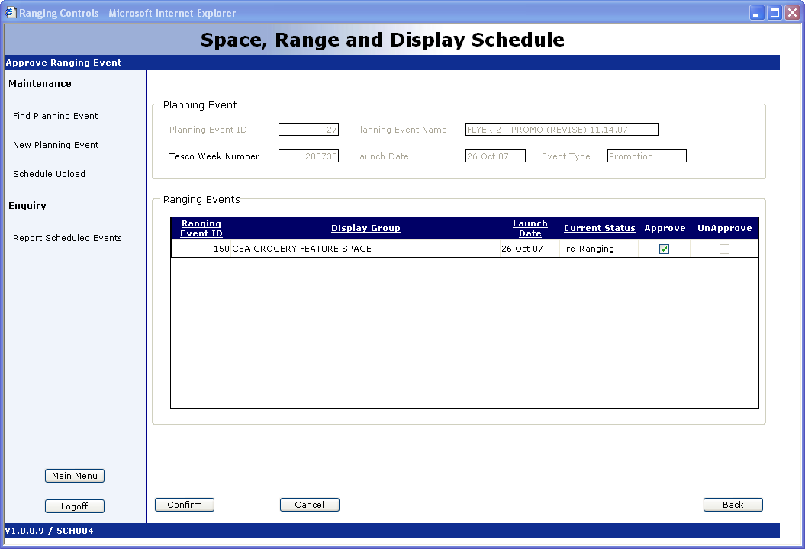

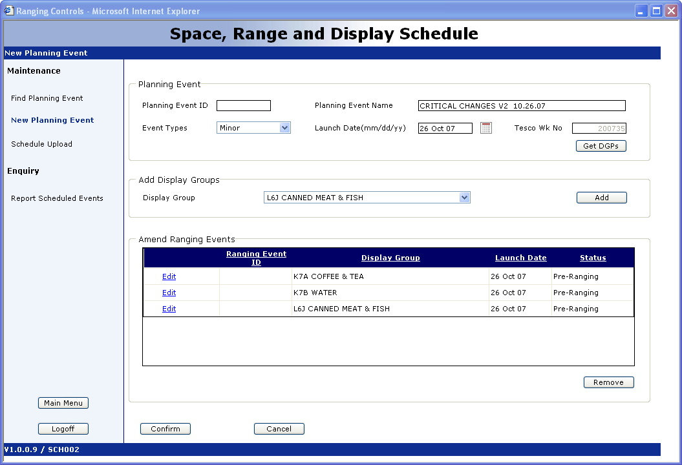

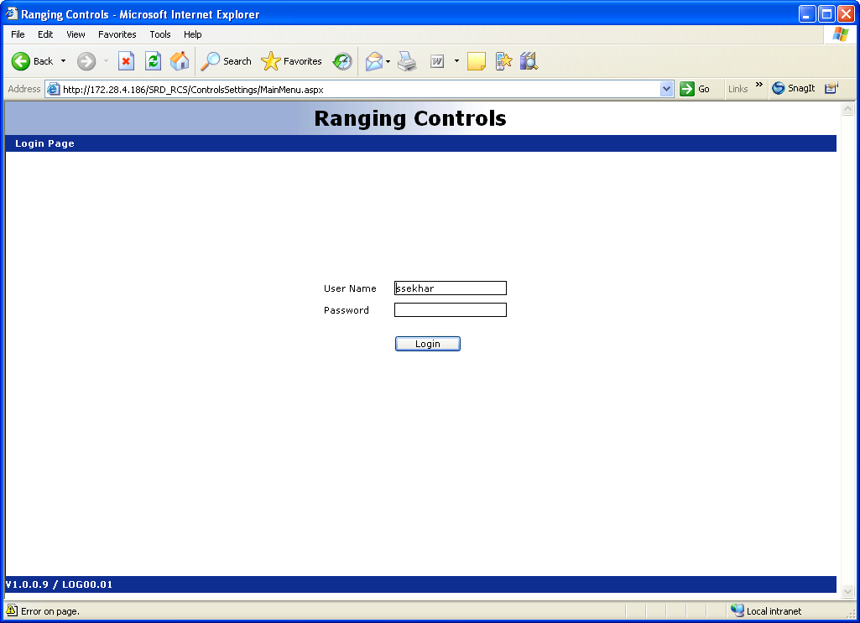 | Login: ssekhar  Password: Tesco@1234
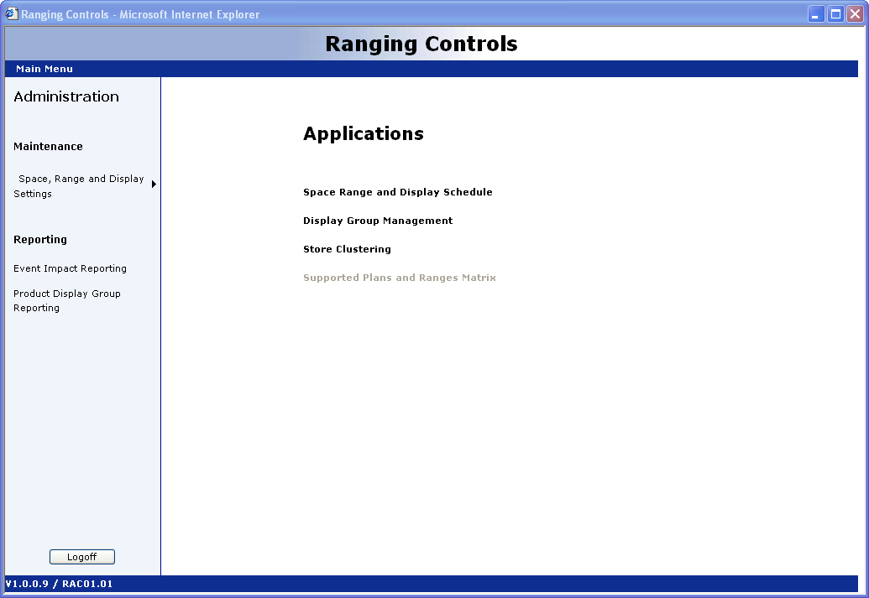 | To Create minor/major/promo/essential select  Space,Range and Display Schedule link
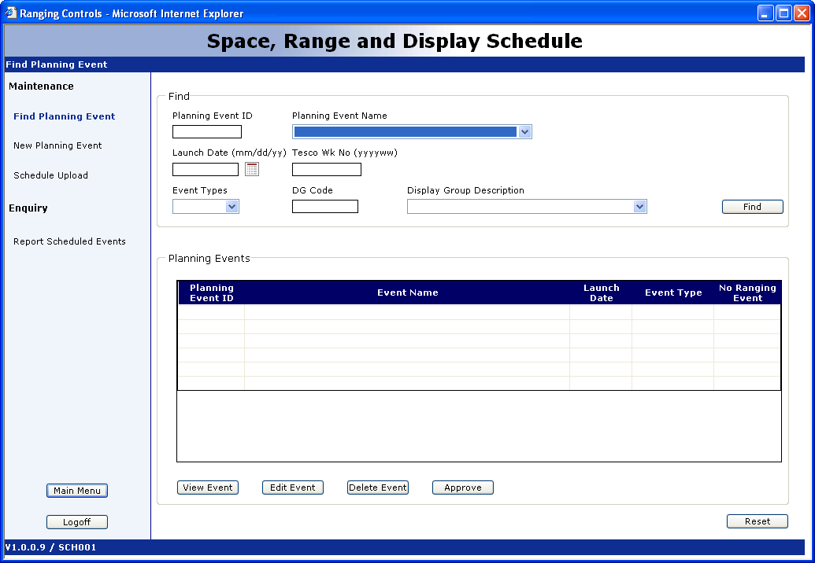 | This will take you to the Find Planning Event window  You can run queries from here Planning ID, Display Code etc.  - To create a new Event click on the New Planning Event link
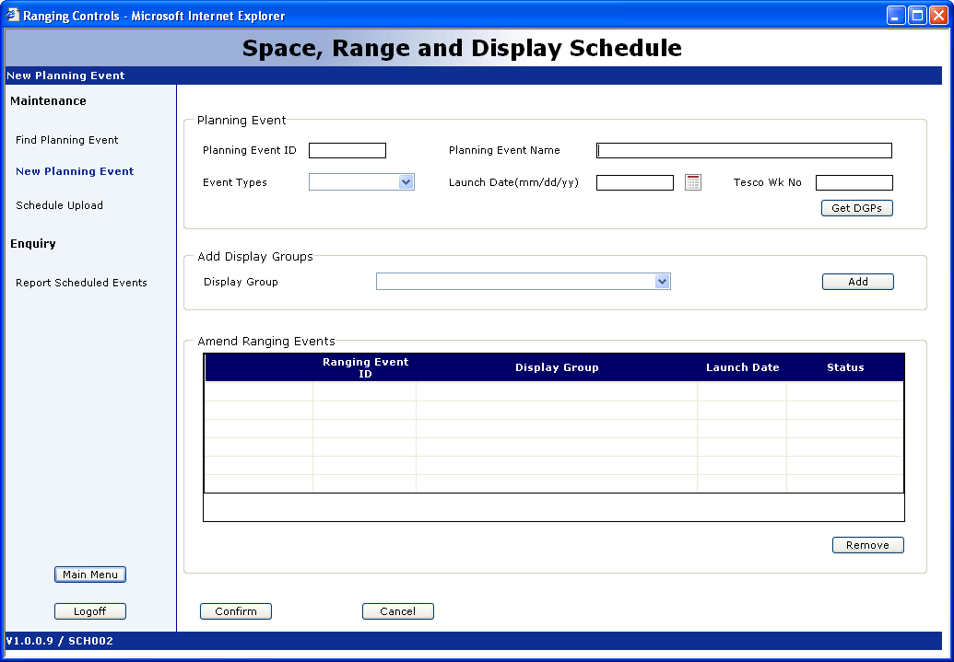 | New Planning Event window  Enter all required info  - Planning Event Name  - Event Types  - Launch Date  - Tesco Wk No (click GDP icon)  You will be prompted with a Date minimum lead time. Select Yes.  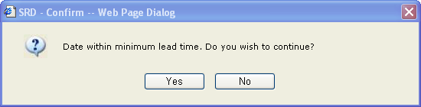
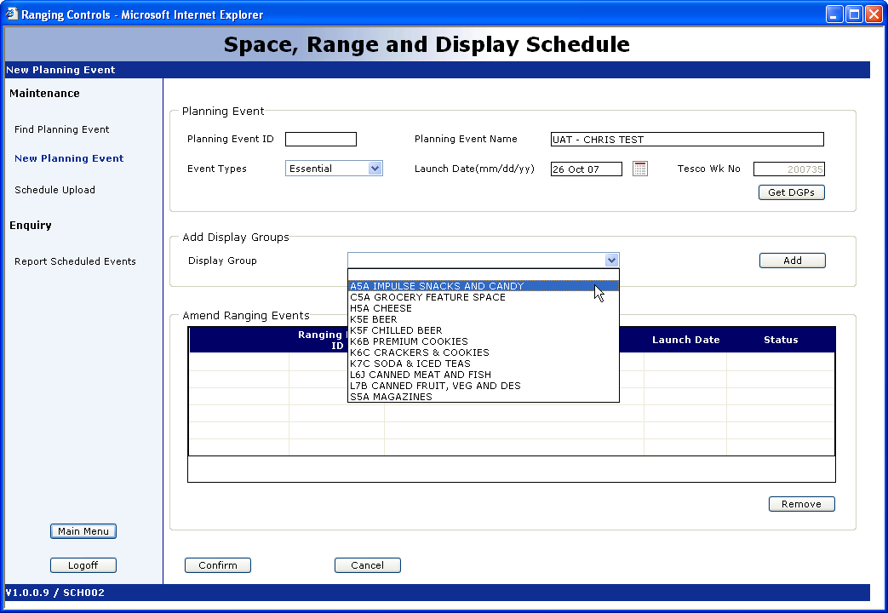 | Click on the display group drop-down field.  Select the display group that you want to add to the Planning event.  Once you’ve selected the display group, click on ADD.

